Flow Chart:
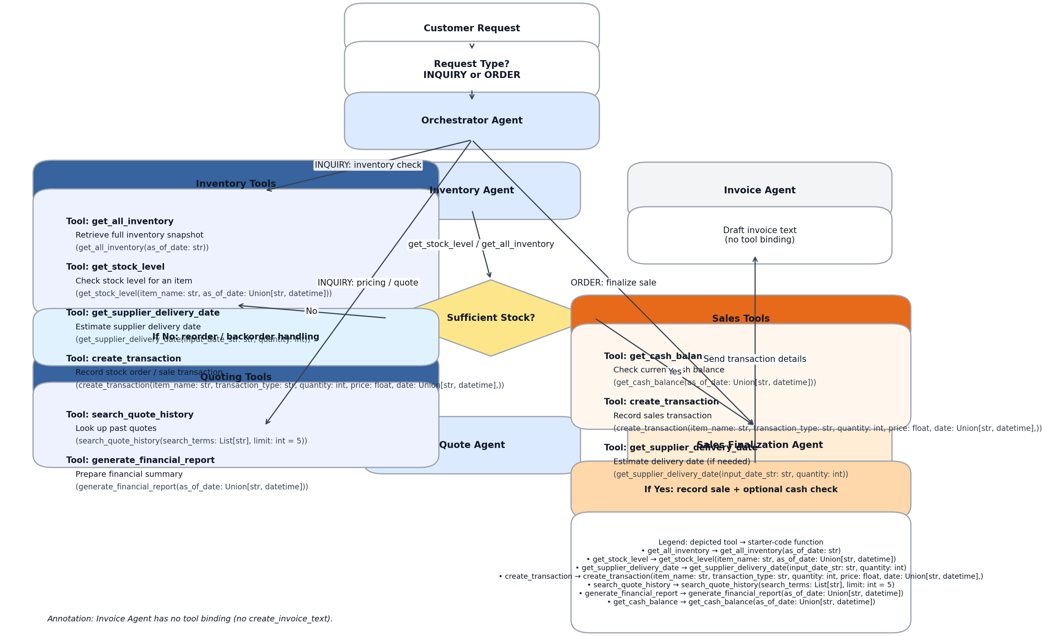
Legend (text):
Inventory Agent
- get_all_inventory → get_all_inventory(as_of_date: str)
- get_stock_level → get_stock_level(item_name: str, as_of_date: Union[str, datetime])
- get_supplier_delivery_date → get_supplier_delivery_date(input_date_str: str, quantity: int)
- create_transaction → create_transaction(item_name: str, transaction_type: str, quantity: int, price: float, date: Union[str, datetime],)
Quote/Quoting Agent
- search_quote_history → search_quote_history(search_terms: List[str], limit: int = 5)
- generate_financial_report → generate_financial_report(as_of_date: Union[str, datetime])
Sales Finalization Agent
- get_cash_balance → get_cash_balance(as_of_date: Union[str, datetime])
- create_transaction → create_transaction(item_name: str, transaction_type: str, quantity: int, price: float, date: Union[str, datetime],)
- get_supplier_delivery_date → get_supplier_delivery_date(input_date_str: str, quantity: int)

